CMGT 1.3 UI-UX Process Report
2023

 |  | Colophon
Date |  | 06 March 2023
Reference |  | 1.3 UI-UX
Version |  | 1.0
Status
Department |  | Creative Media & Game Technologies
Student name |  | Christopher Angelo

© Saxion. All rights reserved. No part of this publication may be reproduced, stored in a retrieval system or transmitted in any form on by any means, electronic, mechanical, photocopying, recording or otherwise, without the prior written permission of the publisher.

Table of Contents

1 Assignment 1: Web 4
1.1 Lab 1 4
1.1.1 Research and analyses 4
1.1.2 Self-assessment 4
1.1.3 Design requirements 7
1.1.4 User interface design 8
1.2 Lab 2 11
1.2.1 User interface design 11
1.2.2 Justification of design 13
1.2.3 Content that needs crediting 16
1.3 Lab 3 17
1.3.1 Heuristic analysis 17
2 Assignment 2: Game 19
2.1 Lab 4 19
2.1.1 Research and analyses 19
2.1.2 UI/UX analyses 20
2.1.3 Background image 21
2.1.4 User assignment(s) 22
2.2 Lab 5 23
2.2.1 User Interface Design 23
2.2.2 Digital design 24
2.3 Lab 6 26
2.3.1 Justification of design 26
2.3.2 Content that needs crediting 27
3 Video presentation 28
3.1 Instructions 28

Assignment 1: Web

Lab 1

Research and analyses

Website URL
https://kemkes.go.id/
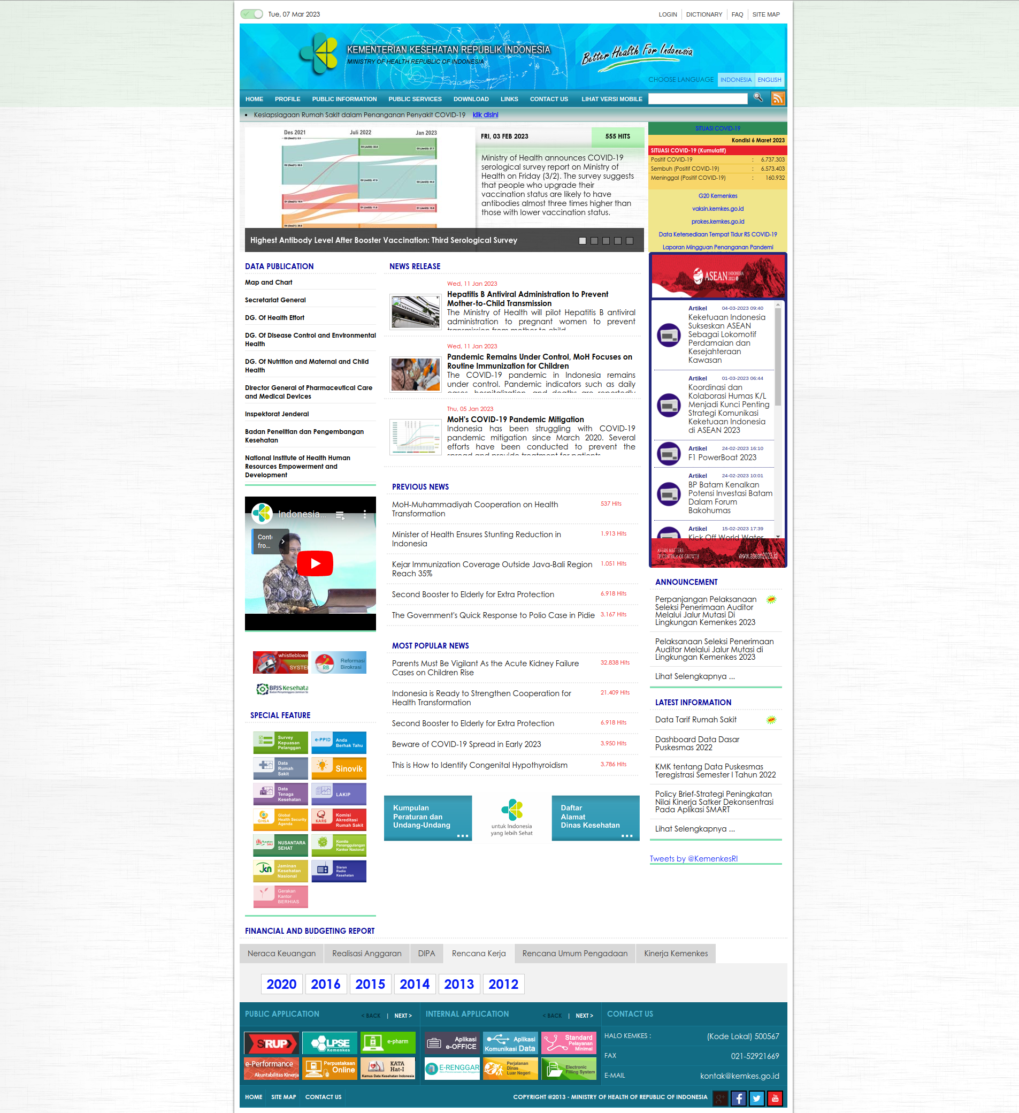

Self-assessment

Interaction Design Principles | What do you notice?  Describe either a good or bad application
1. Visibility | The website has a mostly great contrast between backgrounds and interactive elements (text, buttons list items, etc) making it easy for users to discern between elements. Nit-picking some elements, some part of the site contains poor color contrast that is non-WCAG AA compliant between background and foreground (Deep blue against deep green).  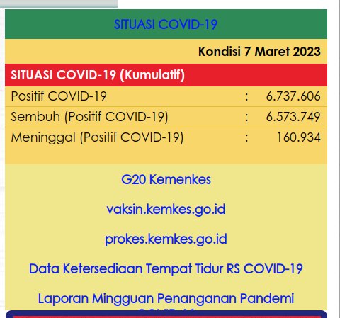  While the primary content of the website is black text on a white background, the websites use too many primary color hues to highlight headings and landmarks, making some elements feel distracting.  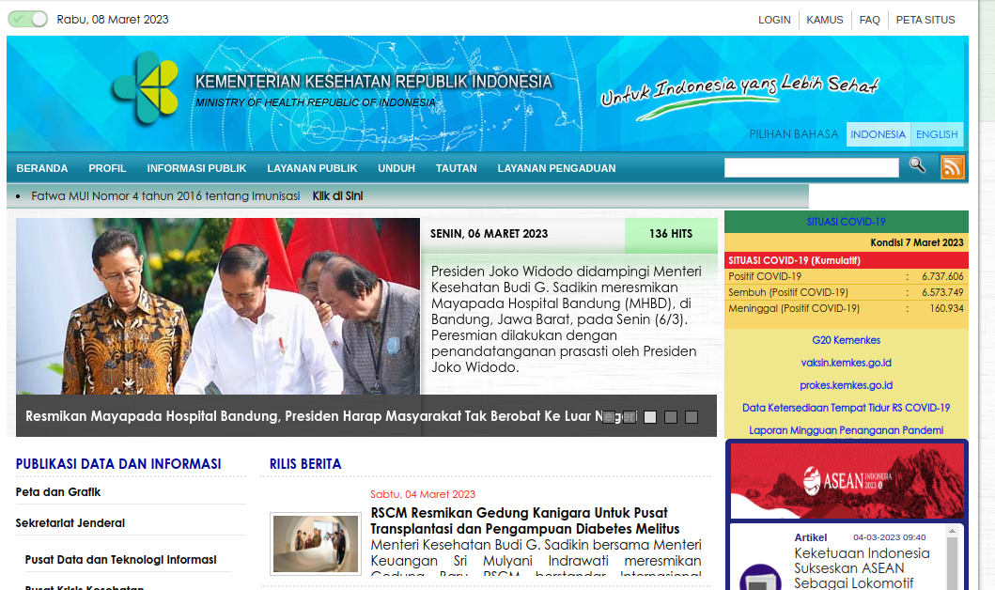  On a modern desktop screen (1080p) without any zoom, the website already displays a borderline adequate size for most elements for it to be legible without extra need of magnification. The size of most text content only contains 1 single font size which is non-WCAG AA compliant for small text (14px vs. 14pt = 18.5px).
2. Feedback | The website has acceptable loading speed and TTI. Though sometimes, it looks like the server is inconsistently unresponsive, having more than 10 seconds of TTFB. Peeking more to the site’s functionality, a lot of the website’s content are animated with transitions which duration feels too long. Also, it seems like the longer I stay on the site, the slower it becomes, hinting that there might be a memory leak issue.  Being a government’s ministry of health website, it lacks clarity whether the website is a public facing website or a private one, containing quick “hot links” to what seems to be confidential / internal sites. Also, some non-related health information seems to be displayed in the front page of the app including balance sheet, budget realization, etc.  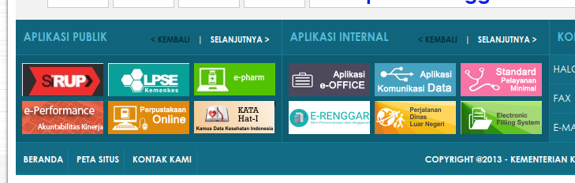  It seems like most of the site’s content are thrown together quickly on a CMS as most information entries contain multi-sub-pages of links.  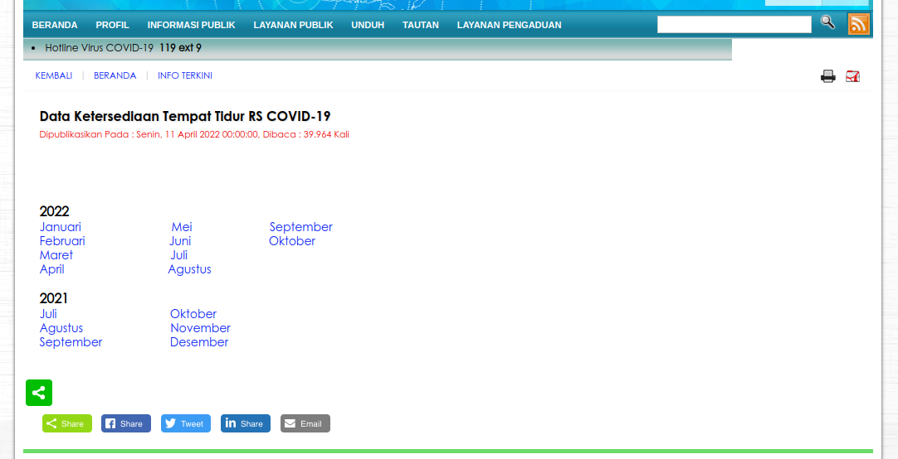
3. Constraints | It would seem like a lot of rarely-used, but available function of the app are broken. For example, article social share buttons that are available but with broken functionality, advertised “special feature” section in the sidebar which contains a lot of dead / invalid links, etc.  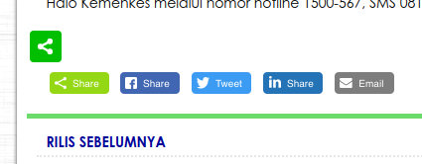  The image carousel on the frontpage of the website allows for non-standard behavior where the carousel are animated horizontally but allows for manual movement vertically.
4. Mapping | This principle relates to how well the design maps the relationship between the controls and the actions they affect. You can evaluate mapping by looking at:  - Labeling: Are the controls and the actions they affect labeled clearly and understandably?  - Positioning: Are the controls and the actions they affect positioned in a way that makes their relationship clear, or are they placed in different parts of the page without any obvious connection?  - Flow: Is the flow of the interaction logical and easy to follow, or are users left guessing about what to do next?
5. Consistency | This principle relates to how consistent the design is throughout the website. You can evaluate consistency by looking at:  - Layout: Is the layout of the website consistent from one page to the next, or does it change in ways that might confuse users?  - Styling: Is the styling of the website consistent from one page to the next, or does it change in ways that might make it hard to recognize the same website?  - Navigation: Is the navigation of the website consistent from one page to the next, or does it change in ways that might make it hard to find the information or tools users need?
6. Affordances | This principle relates to how well the design makes it clear what actions are possible and how they can be performed. You can evaluate affordances by looking at:  - Icons: Are icons used to indicate what actions are possible, and are they clear and easy to understand?  - Labels: Are labels used to indicate what actions are possible, and are they clear and easy to understand?  - Hints: Are hints or tooltips provided to guide users on how to perform certain actions or use certain features?
General
What else did you notice regarding the UI that you couldn't place under one of the principles?

Design requirements

- Hierarchy: The site should have a better hierarchy between elements. The site should utilize different font sizes with different size, weight, variant, and shade of color. In addition, a balance between weight and contrast needs to be achieved by playing around with the content’s spacing and font weight.

- Layout: Currently, the website feels like its throwing everything in one’s face. It feels cluttered as there are too many text content with little space for elements to breathe. The spacing between content also needs tweaking such that it is more consistent and allows elements to have an ample amount of padding / margin.

- Colors: The site should have one (or maybe two) primary colors that are used for primary actions, active navigation element, highlighted elements, etc. Then, it would also need different primary colors for accent, semantic states and others. The said color should then be derived into many shades both darker and lighter.

- Structure: The content of the site should be categorized better with sane article / information grouping, separating between article, essential information and links.

User interface design

Sketches
For this section of the assignment, you will create sketches of a new user interface for the homepage and a random subpage of the website you have analyzed. You do not need to include colors at this stage, and sketches can be made using a gray pencil. Once you have completed your sketches, take a clear picture of them and place them in the table provided below. In addition to the sketches, you should also provide a brief justification for the design choices you have made.

When creating your sketches, keep in mind the design requirements you have identified in the previous section of the assignment. Your sketches should show how your proposed changes will be implemented in the user interface, and how they will improve the user experience. You should also consider principles of good interaction design, such as visibility, feedback, constraints, mapping, consistency, and affordances, when creating your sketches.

In your justification, explain how your new user interface design will address the design requirements you have identified, and how it aligns with principles of good interaction design. Be specific in your reasoning, and provide clear examples to support your design choices.

Sketch of homepage | Justification
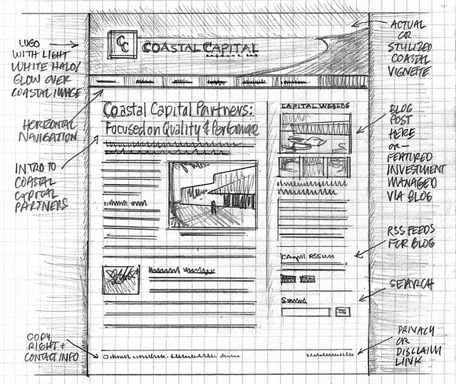  Example sketch (please remove) | Example (please remove):  In the new layout of a news item, a horizontal main navigation has been chosen. This design choice was made to improve the visibility and accessibility of the main menu, as the horizontal layout allows for more space to display menu items and makes it easier for users to quickly identify and select the page they want. The news item in the main menu is highlighted, so users can immediately see where they are on the website, reducing confusion and helping them navigate the website more efficiently.  Only related news items are shown on the right side of the page, with relevant social media channels displayed directly below. This design choice was made to provide a more streamlined and focused user experience, as users are more likely to engage with content that is directly related to their interests. By reducing clutter and presenting only relevant content, we expect to improve the user experience and encourage users to spend more time on the website.  The logo has been given a prominent position at the top of the page and is the same on every page. This design choice was made to provide better consistency across the website, making it easier for users to recognize the website and remember its branding. By providing a consistent logo placement and design, we expect to improve the user experience by reducing confusion and making it easier for users to navigate the website.
Sketch of subpage | Justification

Lab 2

User interface design

Digital design

Tool
What tool have you used to build the interactive prototype?
Figma

URL
Insert (a public) URL of the digital prototype.
https://www.figma.com/file/EXZgXa5aEIp5aPQrQ9kIQV/CMGT---UI%2FUX-Kemkes?node-id=0%3A1&t=pMGCLVCMwRzVpU77-1

Screenshots
Insert some screenshots.
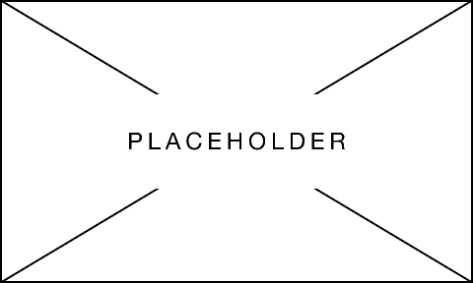

Justification of design
Explain how you took into account the different UI principles from the lecture.

The use of columns, margins and padding
Screenshot(s) | Justification
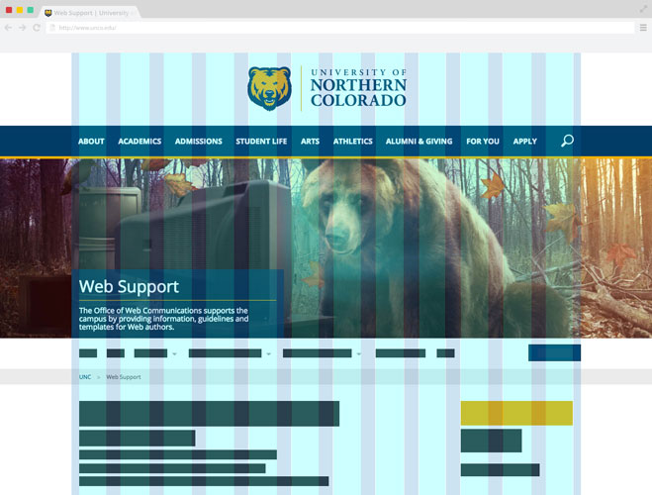  Example (please remove) | Example (please remove):  For my design, I chose to use a 12-column grid system, with 10px margins on the left and right. I chose this layout because it allows me to easily align all the elements of the page, creating a clean and organized design. To implement the grid system, I used a PSD template that had a column layer. By using this template, I was able to quickly and easily set up my layout to match the grid system. I also made sure to align all elements according to the columns to maintain visual consistency throughout the design. In some cases, I had to adjust the width of certain elements slightly to fit within the columns. By using a grid system, I was able to create a visually balanced design that is easy to navigate and enhances the user experience.

The layout (of elements)
Screenshot(s) | Justification
Example (please remove):
In designing the layout of my website, I focused on creating a clear and intuitive order for the different elements of the user interface. I prioritized the most important elements, such as the main navigation and key calls-to-action, by placing them prominently on the page. I also made sure to group related elements together, such as placing social media links together in the footer, to make it easy for users to find what they are looking for. To improve the visual hierarchy, I used larger fonts and bolder colors for more important elements, and kept the layout of less important elements more subtle. Additionally, I made sure to consider the flow of the user's eye across the page, using spacing and positioning to create a natural progression from one element to the next. By carefully considering the layout of elements, I was able to create a user-friendly design that supports the goals of the website and enhances the overall user experience.

The use of colors
Screenshot(s) | Justification
Example (please remove):
In designing my website, I paid careful attention to the use of colors to create a visually appealing and engaging user interface. I used a limited color palette to create a cohesive design and focused on choosing colors that support the overall goals of the website. For example, I used a blue color for buttons and links to encourage users to click through to other pages, and I used a green color to highlight positive actions, such as "Submit" buttons. I also made sure to use contrasting colors to make key elements, such as buttons and calls-to-action, stand out from the background. Additionally, I considered the emotions and feelings that different colors can evoke, using warm colors, such as orange and yellow, to create a friendly and welcoming vibe. Overall, by using color thoughtfully and strategically, I was able to create a visually appealing design that supports the goals of the website and enhances the user experience.

The use of fonts
Screenshot(s) | Justification
Example (please remove):
For the use of fonts in my design, I focused on choosing typography that is legible and easy to read, while also supporting the overall look and feel of the website. I chose two complementary fonts, one for headings and one for body text, that work well together and are easy on the eyes. I made sure to use a larger font size for headings to create a clear visual hierarchy, and a smaller font size for body text to improve readability. Additionally, I made sure to use sufficient line spacing and kerning to ensure that the text is easy to scan and read. I also considered the use of bold and italic styles to create emphasis and highlight important information. Overall, by carefully selecting and using typography in my design, I was able to create a visually appealing and user-friendly design that supports the goals of the website.

The design of icons and/or buttons
Screenshot(s) | Justification
Example (please remove):
For the design of icons and buttons on my website, I focused on creating intuitive and visually appealing user interface elements that are easy to understand and use. I used a consistent style and color scheme for all icons and buttons to create a cohesive look and feel. I also made sure to use clear and easily recognizable symbols for icons to improve usability and help users quickly understand their meaning. For buttons, I used a prominent color and a clear and concise label to make them stand out and encourage users to click on them. I also made sure to use appropriate button styles for different types of actions, such as a "Submit" button for form submissions and a "Cancel" button for canceling an action. Overall, by designing icons and buttons that are visually appealing, consistent, and easy to understand, I was able to create a user-friendly design that enhances the overall user experience.

If applicable, other design principles you applied.
Consider other design principles, such as contrast, alignment, visual hierarchy, or any other design elements that you feel are important to the overall success of your design. To justify your design choices, explain how these other design principles support the overall design aesthetic and improve the usability and engagement of the website.

Screenshot(s) | Justification

Content that needs crediting
List of free assets (icons, fonts, buttons, images, etc.) that were not made by you, and a link to the source of these assets.

Asset | Location (in your design) | Source
Font – Inter | Body text | https://rsms.me/inter
Font – IBM Plex Sans | Heading text | https://ibm.com/plex
Iconset – Hero Icons | General iconography set | https://heroicons.com/
Iconset – Simple Icons | Brand iconography set | https://heroicons.com/
Colorset – Tailwind v3.0 |  | https://tailwindcss.com/
Images – Unsplash | Article images | https://unsplash.com/

Lab 3

Heuristic analysis
Instructions:
- Review the 10 heuristics for user interface design as covered in lecture.
- Test the interactive prototype of a fellow student for usability issues, and make a note of any issues you encounter.
- Analyze your results based on the 10 heuristics, and identify which heuristic(s) each issue violates.
- Prioritize the issues based on severity, and come up with recommendations for how to address each issue.

The 10 Heuristics in brief:

- Visibility of system status  The system should always keep users informed about what is going on through appropriate feedback within a reasonable time.  - Match between system and the real world  The system should speak the users' language, with words, phrases and concepts familiar to the user, rather than system-oriented terms. Follow real-world conventions, making information appear in a natural and logical order.  - User control and freedom  Users often choose system functions by mistake and will need a clearly marked "emergency exit" to leave the unwanted state without going through an extended dialogue. Support undo and redo.  - Consistency and standards  Users should not have to wonder whether different words, situations, or actions mean the same thing.  - Error prevention  Even better than good error messages is a careful design that prevents a problem from occurring in the first place. Either eliminate error-prone conditions or check for them and present users with a confirmation option before committing to the action. | - Recognition rather than recall  Minimize the user's memory load by making objects, actions, and options visible. The user should not have to remember information from one part of the dialogue to another. Instructions for use of the system should be visible or easily retrievable whenever appropriate.  - Flexibility and efficiency of use  Accelerators — unseen by the novice user — may often speed up the interaction for the expert user such that the system can cater to both inexperienced and experienced users. Allow users to tailor frequent actions.  - Aesthetic and minimalist design  Dialogues should not contain information that is irrelevant or rarely needed. Every extra unit of information in a dialogue competes with the relevant information units and diminishes their relative visibility.  - Help users recognize, diagnose, and recover from errors  Should be expressed in plain language (no codes), precisely indicate the problem, and constructively suggest a solution.  - Help and Documentation  Even though it is better if the system can be used without documentation, it may be necessary to provide help and documentation. Any such information should be easy to search, focused on the user's task, list concrete steps to be carried out, and not be too large.

Name of student you reviewed:
URL of prototype:
 |  | Choose which heuristic(s) apply
Issues found: |  | 1 | 2 | 3 | 4 | 5 | 6 | 7 | 8 | 9 | 10
1 | [Example:  Issue: The user is unable to find the search function on the homepage.  Description: The search function is not prominently displayed on the homepage and the user has to scroll down the page to find it.  Heuristic violated: Visibility of system status.  Explanation: According to this heuristic, the system should always keep the user informed about what is going on through appropriate feedback within a reasonable time. In this case, the search function is not prominently displayed on the homepage, which means the user may not be aware of its availability. As a result, the user may become frustrated and give up searching for the function, leading to a poor user experience.]  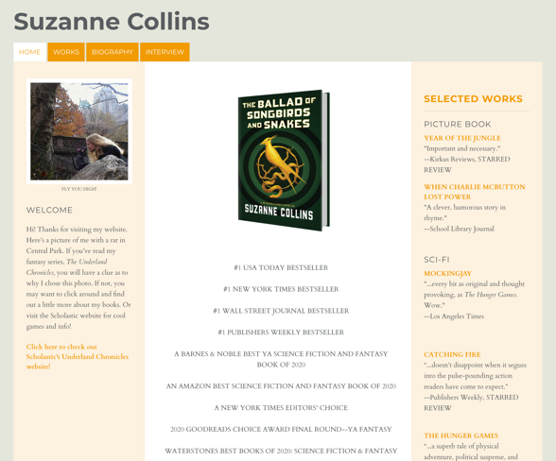 | X
2
3
4
5
6

Assignment 2: Game

Lab 4

Research and analyses

Screenshots

Reference game #1

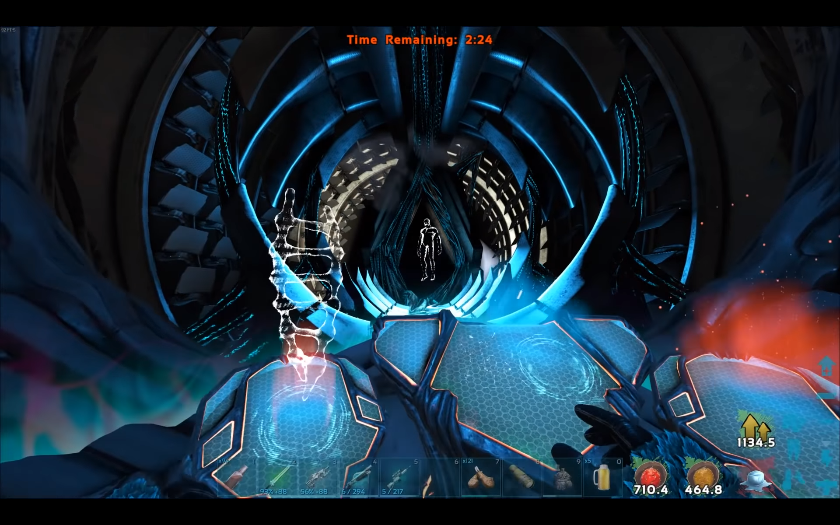
Game title #1: ARK: Survival Evolved
Reference game #2
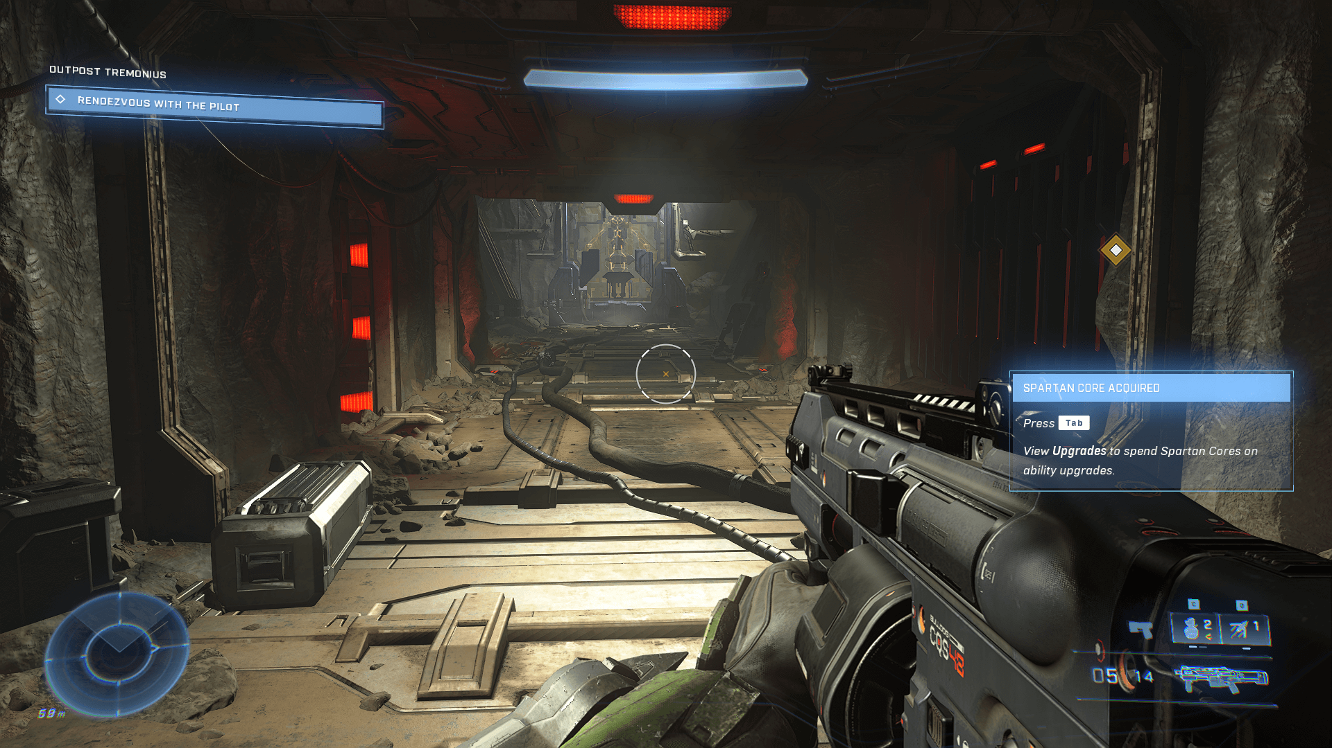
Game title #2: Halo Infinite
Reference game #3

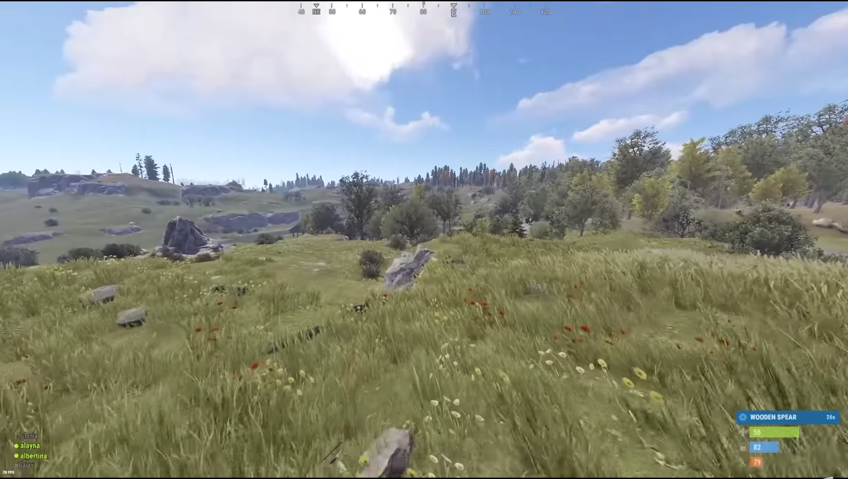
Game title #3: Rust

UI/UX analyses

Reference game #1
Checkpoints | Analyses
- Goal & achievements | [Describe what you noticed, either good or bad]  [Explain why]
- Orientation | [Describe what you noticed, either good or bad]  [Explain why]
- Abilities | [Describe what you noticed, either good or bad]  [Explain why]
- Resources | [Describe what you noticed, either good or bad]  [Explain why]
- Composition | [Describe what you noticed, either good or bad]  [Explain why]
Summary
[Briefly summarize what you have learned and what are important points for you to take away with designing your own HUD. This should include a summary of the key principles of HUD design that you have identified and any insights you have gained from analyzing the existing examples.]

Reference game #2
Checkpoints | Analyses
- Goal & achievements | [Describe what you noticed, either good or bad]  [Explain why]
- Orientation | [Describe what you noticed, either good or bad]  [Explain why]
- Abilities | [Describe what you noticed, either good or bad]  [Explain why]
- Resources | [Describe what you noticed, either good or bad]  [Explain why]
- Composition | [Describe what you noticed, either good or bad]  [Explain why]
Summary
[Briefly summarize what you have learned and what are important points for you to take away with designing your own HUD. This should include a summary of the key principles of HUD design that you have identified and any insights you have gained from analyzing the existing examples.]

Reference game #3
Checkpoints | Analyses
- Goal & achievements | [Describe what you noticed, either good or bad]  [Explain why]
- Orientation | [Describe what you noticed, either good or bad]  [Explain why]
- Abilities | [Describe what you noticed, either good or bad]  [Explain why]
- Resources | [Describe what you noticed, either good or bad]  [Explain why]
- Composition | [Describe what you noticed, either good or bad]  [Explain why]
Summary
[Briefly summarize what you have learned and what are important points for you to take away with designing your own HUD. This should include a summary of the key principles of HUD design that you have identified and any insights you have gained from analyzing the existing examples.]

Background image
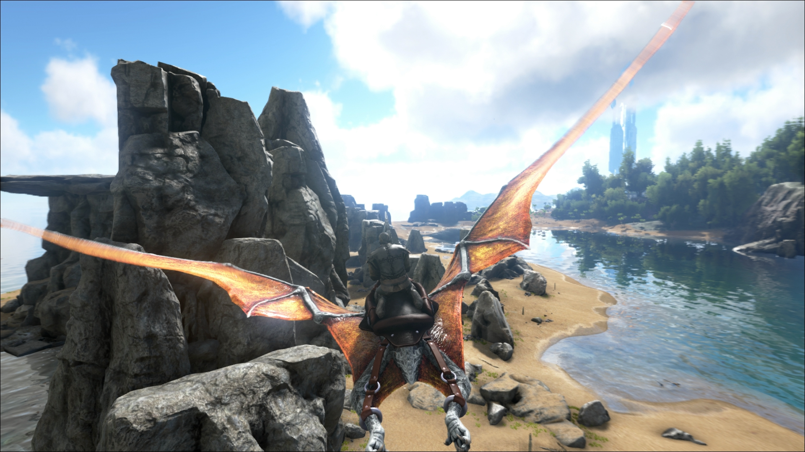
Source: WCCF Tech Article:
ARK: Survival Evolved Xbox One Preview – Living With Dinosaurs
https://wccftech.com/ark-survival-evolved-xbox-preview-living-dinosaurs/

User assignment(s)
In this assignment, you will use the provided table to create user interface (UI) elements for your first-person shooter game. The UI elements will allow the player to complete specific tasks and receive feedback on their progress in the game.

Narrative: The game's UI should clearly communicate the player's current mission or quest, the tasks they need to complete, their latest achievements, and their orientation towards key locations. Additionally, the UI should communicate the player's current weapons and abilities, including information on ammo and power levels, and allow the player to swap between weapons and abilities.

Instructions:
- Use the table below to create UI elements for the game.
- Replace the red text in the table with your own choice of narrative, specific to the game you are designing.
- Ensure that each UI element provides clear and concise information to the player, and is designed in a way that is intuitive and easy to use.
- Test your UI elements in a hi-fi prototype, and ensure that they provide the necessary feedback and information to the player as they progress through the game.

Table: Tasks & UI Information Required to Verify Your UI Design
Criteria | Description
Current active mission/quest in the game: | reach the [mission location here]
Find latest player achievement: | completed [name of previous completed mission]
Player score | current [scored points] or [amount currency]
Current task/challenge: | [capture or kill] the [name item] at [name location]
What direction should the player move? | [different direction north, east south or west]
Current active weapon: | [name of weapon]
Ammo or health: | [describe information of almost broken / depleted current weapon or ability]
Player interactive tasks using your interactive hi-fi prototype with UI feedback: | activate [weapon or ability] selection and select [name the weapon or ability]

Lab 5

User Interface Design

HUD sketch
Design a Lo-Fi UI sketch of a HUD, with a minimum resolution of 1920x1080px. Once ready, insert screenshots to the table below and a justification for your design.

Sketches | Justification
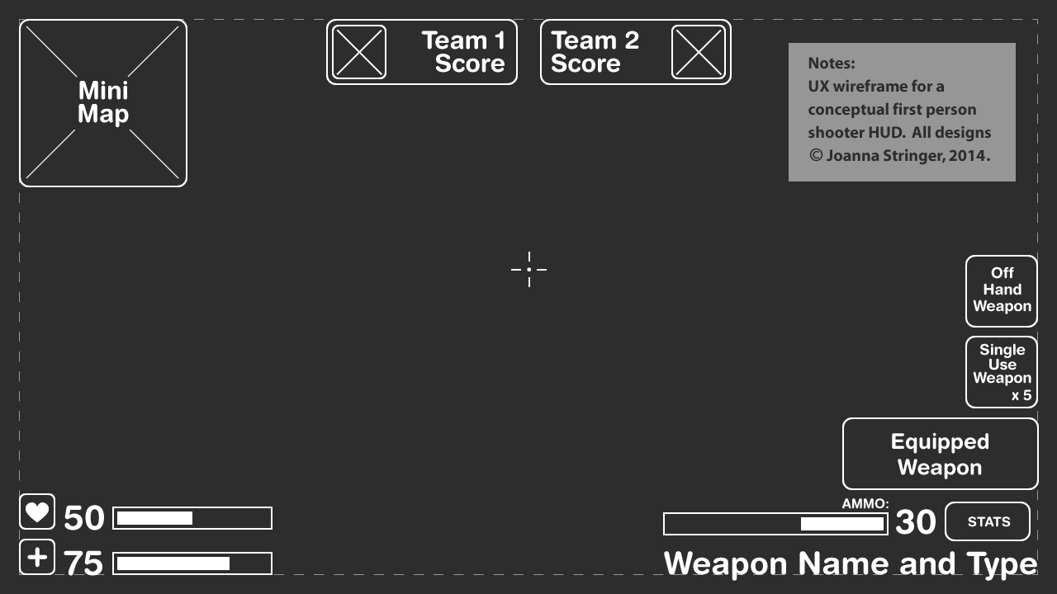  [Random example of lo-fi UI, does not correspond with justification. Please remove] | Example  [For my HUD design, I aimed to prioritize simplicity and clarity in order to ensure that the player could easily comprehend the important information being presented. I implemented a minimalist design approach, utilizing bold text and straightforward icons to provide the player with quick and accessible updates on their status.  In the top left corner of the HUD, I placed the current mission and task information, recognizing the critical role this information plays in helping the player stay on track and focused. Additionally, I placed the player's score and currency in the top right corner to ensure that the player receives clear feedback on their progress and can feel a sense of achievement as they continue to earn points.  The lower section of the HUD displays the player's current weapon and ammo count, as well as their health and shield levels. These elements are positioned near the center of the screen, enabling the player to quickly and easily monitor their resources and make strategic decisions based on their status. I also integrated a simple compass and directional indicator to further assist the player in maintaining orientation and identifying where to go next.  Throughout the design process, I incorporated principles from our lectures, such as the importance of clear and concise communication, the use of easily recognizable icons and typography, and the creation of a cohesive and intuitive layout. By doing so, I aimed to provide a highly functional and user-friendly HUD design that will enhance the player's overall experience.

Digital design
Now that you have created a lo-fi sketch of your HUD design, it's time to create a high-fidelity (hi-fi) prototype of your final design using a digital drawing tool of your choice.

When designing your hi-fi prototype, remember to consider the principles covered in the first three labs, such as the correct application of margins, layout of elements, color, fonts, icons, and buttons. Additionally, you should incorporate various interactive elements into your design to make it fully functional and enhance the player's experience. Think about how to implement interactions like switching weapons, viewing the map, and checking the inventory in a way that is intuitive and easy to use.

Furthermore, keep in mind that many games are primarily keyboard-controlled, with the mouse being used for orientation and other actions only in certain circumstances. Consider how your design will be controlled with the keyboard and ensure that it is easy and intuitive for the player to use.

Please pay attention! You only need to design the interaction with the HUD. You don't need to simulate the gameplay.

Tool
What tool have you used to build the interactive prototype?

URL
Insert (a public) URL of the digital prototype.

Instructions
Give a brief instruction on how to play the game, if you used keyboard shortcuts.

Screenshots

Insert some screenshots.

Lab 6

Justification of design
Now that you have created a hi-fi prototype of your UI HUD design, it's time to justify your design choices based on the UI principles you have learned throughout the course.

Instructions:
- Review the final design of your UI HUD, and take note of the various elements and design choices you have made. Consider factors such as color, typography, layout, and interactivity.
- Choose at least four UI principles from the course that you believe are most relevant to your design, and write a brief explanation of how each principle has influenced your design. Be sure to provide specific examples and illustrations from your design.
- For each UI principle, describe how it helps to improve the user experience of your UI HUD design. Discuss the specific ways in which your design incorporates this principle, and how it contributes to the overall effectiveness of the design.
- Conclude your justification by summarizing the key strengths of your UI HUD design, and how it meets the needs and expectations of your target audience. Consider aspects such as usability, functionality, and aesthetics.
- Include relevant screenshots or other visual materials to support your justification, and be sure to cite any sources or references used in your analysis.

Example:
Simplicity: To make the design easy to understand and use, I limited the number of elements on the HUD and used a minimalist style. I used a limited color palette of gray and blue to convey important information such as health, ammo, and objectives. I also used simple, geometric icons to represent actions and items, making them easy to recognize and understand.

Consistency: I maintained consistency throughout the design by using a consistent visual style and layout for each element of the HUD. Each element is aligned to a grid system, and each section is separated by a thin line to clearly differentiate them from each other. I also used consistent typography and color throughout the design, making it easy for the player to quickly identify different elements of the HUD.

Visual Hierarchy: To prioritize the most important information, I used a clear visual hierarchy in the design. The most important elements, such as health and ammo, are larger and more prominent than less important elements such as objectives or the minimap. I also used color and typography to create a clear distinction between elements, with important information displayed in bold, larger text, and less important information displayed in smaller, lighter text.

By incorporating these UI principles into my design, I believe I have created an effective and user-friendly UI HUD that allows the player to easily understand their status and navigate the game world. The design is clear, concise, and visually appealing, making it a valuable addition to the overall game experience.

Content that needs crediting
List of free assets (icons, fonts, buttons, images, etc.) that were not made by you, and a link to the source of these assets.

Asset | Location (in your prototype) | Source

Video presentation

For the final assessment of your prototypes, you are required to record a video presentation of your designs. The video should not exceed 5 minutes in length and must showcase both your prototypes: the website and the HUD for a game. In this video, you will have the opportunity to demonstrate your design skills, showcase your prototypes, and justify your design choices by incorporating the principles and theories you have learned in class. Please carefully follow the instructions provided to ensure that your video is clear, concise, and effectively demonstrates your design process.

Instructions

- Plan and practice your presentation beforehand: Write an outline of what you want to cover in your video and practice speaking about it. Rehearse your timing to make sure you can fit everything into 5 minutes.
- It is suggested to use the Kaltura screen recording software from video.saxion.nl
- Try to speak clearly and at a moderate pace. Avoid using slang that might be confusing for your teacher.
- Show and explain your prototypes:
  - Show how the different UI elements in your prototype interact with each other and with the user.
  - Demonstrate how the user can navigate through the interface and accomplish tasks.
  - Emphasize any unique or innovative interactive features you have included in your design.
- Justify your design choices:
  - Clearly explain the design decisions you made and the reasoning behind them.
  - Reference the UI/UX theory and principles you used to inform your design choices.
  - Provide specific examples of how your design decisions improve the user experience and meet the usability requirements for different contexts.
- Submit your video via video.saxion.nl. Don’t forget to set the video to either unlisted or public.
- Share the URL on Blackboard at the hand-in section.

